Java Technolgy Overview

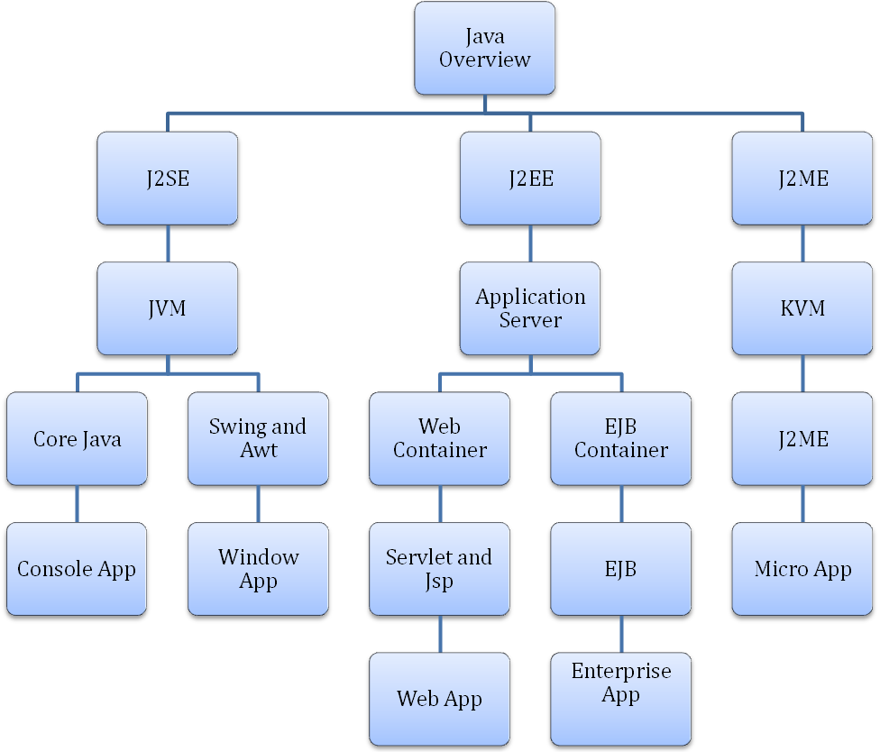

Java is providing technologies and runtime environment to develop all the kind the application used in the industry.

Applications are majorly categories in two types in JAVA.

- Stand alone application
An application is running on single machine without depending on other machines. It is called stand alone application like calculator, notepad and etc.
- Distribute application
An application is running on server machine and distributing services to client machine like database server, web application and etc.
There are 3 distinct editions of the Java Platform:
Java 2 Platform, Enterprise Edition:
The edition of the Java platform that is targeted at enterprises to enable development, deployment, and management of multi-tier server-centric applications.
Java 2 Platform, Standard Edition:
The edition of the Java platform that enables development, deployment, and management of cross-platform, general-purpose applications.
Java 2 Platform, Micro Edition:
The edition of the Java platform that is targeted at small, standalone or connectable consumer and embedded devices to enable development, deployment, and management of applications that can scale from smart cards through mobile devices and set-top boxes to conventional computing devices.

Application Architecture

Applications consist of three parts.
- PL is called Presentation Layer to develop the user interface in the application for receiving input data from user and for displaying output result to user.

- BL is called Business Login Layer to do all business services like data validation, processing.

- DL is called Data Layer for storing the data in the Database server and retrieving the data from it.

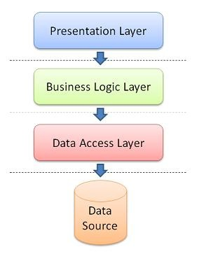

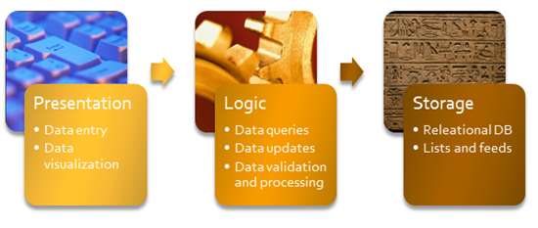
Single Tier Application
An application consists of all three layers and is running on single individual machine without depend other machines.
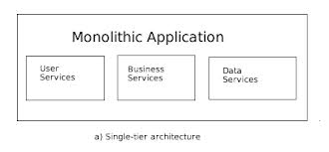

Two Tier Application
An application is divided into two parts. It is also called Client and server architecture applications.
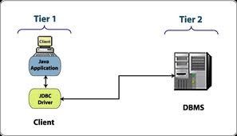

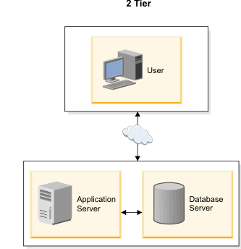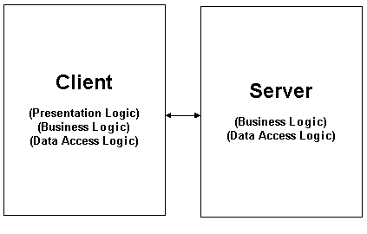

Three Tier Application

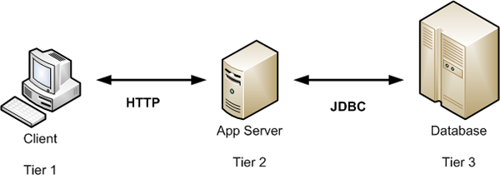

Four Tier Application

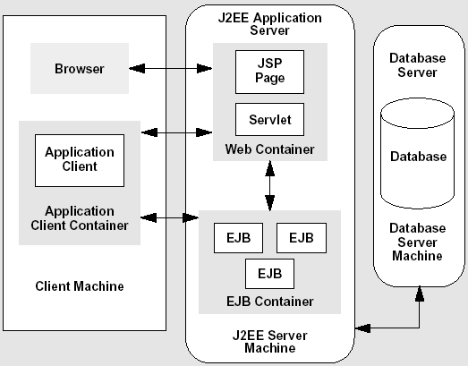

Java Technologies

Application Type | Technology Name | Java Platform
Console Application | Core JAVA | JVM
Windows Application | Swing, AWT | JVM
Web Applications | Servlet and JSP | Web Container
Enterprise Application | EJB | EJB Container
Micro Application | J2ME | KVM

Java EE Application Model

The Java EE application model begins with the Java programming language and the Java virtual machine. The proven portability, security, and developer productivity they provide forms the basis of the application model. Java EE is designed to support applications that implement enterprise services for customers, employees, suppliers, partners, and others who make demands on or contributions to the enterprise. Such applications are inherently complex, potentially accessing data from a variety of sources and distributing applications to a variety of clients.

To better control and manage these applications, the business functions to support these various users are conducted in the middle tier. The middle tier represents an environment that is closely controlled by an enterprise’s information technology department. The middle tier is typically run on dedicated server hardware and has access to the full services of the enterprise.

The Java EE application model defines architecture for implementing services as multitier applications that deliver the scalability, accessibility, and manageability needed by enterprise-level applications. This model partitions the work needed to implement a multitier service into two parts: the business and presentation logic to be implemented by the developer, and the standard system services provided by the Java EE platform. The developer can rely on the platform to provide solutions for the hard systems-level problems of developing a multitier service.

Distributed application:
Client and server architecture programs are called distributed application.
The J2EE platform uses a distributed multitier application model for enterprise applications. Application logic is divided into components according to function, and the various application components that make up a J2EE application are installed on different machines depending on the tier in the multitier
J2EE environment to which the application component belongs.
- Client-tier components run on the client machine.
- Web-tier components run on the J2EE server.
- Business-tier components run on the J2EE server.
- Enterprise information system (EIS)-tier software runs on the EIS server.

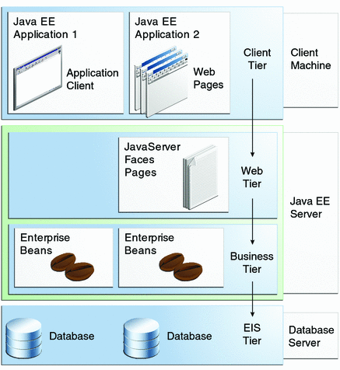

J2EE Components
- Application clients and applets are components that run on the client.
- Java Servlet and Java Server Pages™ (JSP™) technology components are web components that run on the server.
- Enterprise JavaBeans™ (EJB™) components (enterprise beans) are business components that run on the server.

J2EE Clients

Web Clients

A web client consists of two parts: (1) dynamic web pages containing various types of markup language (HTML, XML, and so on), which are generated by web components running in the web tier, and (2) a web browser, which renders the pages received from the server.

Applets

A web page received from the web tier can include an embedded applet. An Applet is a small client application written in the Java programming language that executes in the Java virtual machine installed in the web browser. However, Client systems will likely need the Java Plug-in and possibly a security policy file In order for the applet to successfully execute in the web browser.

Application Clients
An application client runs on a client machine and provides a way for users to handle tasks that require a richer user interface than can be provided by a markup language. It typically has a graphical user interface (GUI) created from the Swing or the Abstract Window Toolkit (AWT) API, but a command-line interface is certainly possible. Application clients directly access enterprise beans running in the business tier. However, if application requirements warrant it, an application client can open an HTTP connection to establish communication with a Servlet running in the web tier.

Server Communication

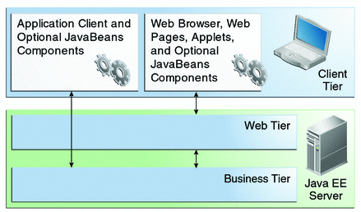

Web Components

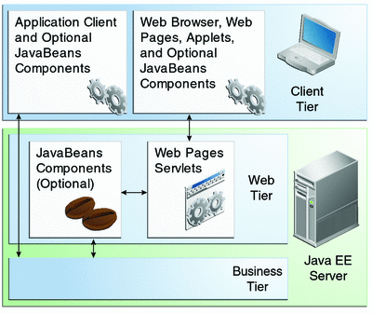

J2EE web components are either Servlets or pages created using JSP technology
(JSP pages) . Servlets are Java programming language classes that dynamically
Process requests and construct responses. JSP pages are text-based documents that execute as Servlets but allow a more natural approach to creating static content.

Business Components

Business code, which is logic that solves or meets the needs of a particular business domain such as banking, retail, or finance, is handled by enterprise beans running in the business tier. Figure 1–4 shows how an enterprise bean receives data from client programs, processes it (if necessary), and sends it to the enterprise information system tier for storage. An enterprise bean also retrieves data from storage, processes it (if necessary), and sends it back to the client program.
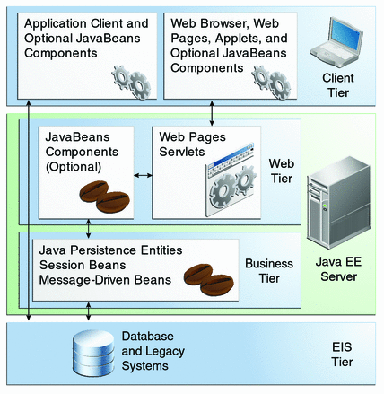

Enterprise Information System Tier
The enterprise information system tier handles EIS software and includes enterprise infrastructure systems, such as enterprise resource planning (ERP), mainframe transaction processing, database systems, and other legacy information systems. For example, Java EE application components might need access to enterprise information systems for database connectivity.

J2EE Containers

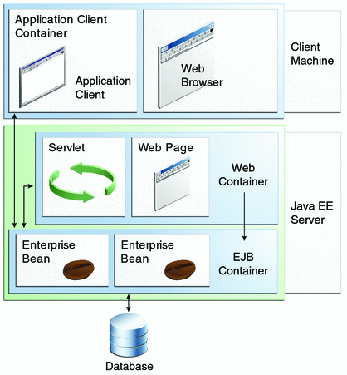

- Java EE server: The runtime portion of a Java EE product. A Java EE server provides EJB and web containers.
- Enterprise JavaBeans (EJB) container: Manages the execution of enterprise beans for Java EE applications. Enterprise beans and their container run on the Java EE server.
- Web container: Manages the execution of web pages, servlets, and some EJB components for Java EE applications. Web components and their container run on the Java EE server.
- Application client container: Manages the execution of application client components. Application clients and their container run on the client.
- Applet container: Manages the execution of applets. Consists of a web browser and Java Plug-in running on the client together.
J2EE Product Provider

Roles in J2EE

- Tool Provider
The tool provider is the company or person who creates development, assembly, and packaging tools used by component providers, assemblers, and deployers.
- Application Component Provider
The application component provider is the company or person who creates web components, enterprise beans, applets, or application clients for use in J2EE applications.
- Enterprise Bean Developer
An enterprise bean developer performs the following tasks to deliver an EJB JAR file that contains the enterprise bean(s):
  - Writes and compiles the source code
  - Specifies the deployment descriptor
  - Packages the .class files and deployment descriptor into the EJB JAR file
- Web Component Developer
A web component developer performs the following tasks to deliver a WAR file containing the web component(s):
  - Writes and compiles Servlet source code
  - Writes JSP and HTML files
  - Specifies the deployment descriptor
  - Packages the .class, .jsp, and.html files and deployment descriptor into the WAR file.
- Application Client Developer
An application client developer performs the following tasks to deliver a JAR file containing the application client:
  - Writes and compiles the source code
  - Specifies the deployment descriptor for the client
  - Packages the .class files and deployment descriptor into the JAR file
- Application Assembler
The application assembler is the company or person who receives application modules from component providers and assembles them into a J2EE application EAR file. The assembler or deployer can edit the deployment descriptor directly or can use tools that correctly add XML tags according to interactive selections. A software developer performs the following tasks to deliver an EAR file containing the J2EE application:
  - Assembles EJB JAR and WAR files created in the previous phases into a J2EE application (EAR) file
  - Specifies the deployment descriptor for the J2EE application
  - Verifies that the contents of the EAR file are well formed and comply with the J2EE specification
- Application Deployer and Administrator
A deployer or system administrator performs the following tasks to install and configure a J2EE application:
Adds the J2EE application (EAR) file created in the preceding phase to the J2EE server
Configures the J2EE application for the operational environment by modifying the deployment descriptor of the J2EE application
Verifies that the contents of the EAR file are well formed and comply with the J2EE specification
Deploys (installs) the J2EE application EAR file into the J2EE server

Java EE 6 APIs
shows the relationships among the Java EE containers.
Figure 1-7 Java EE Containers
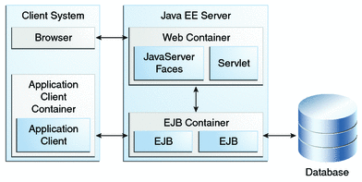
shows the availability of the Java EE 6 APIs in the web container.

Figure 1-8 Java EE APIs in the Web Container
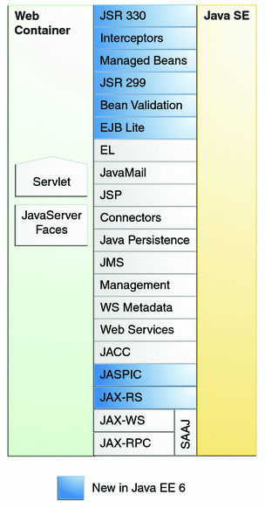
shows the availability of the Java EE 6 APIs in the EJB container.

Figure 1-9 Java EE APIs in the EJB Container
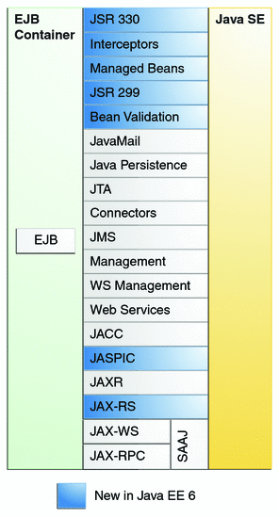
shows the availability of the Java EE 6 APIs in the application client container.

Figure 1-10 Java EE APIs in the Application Client Container
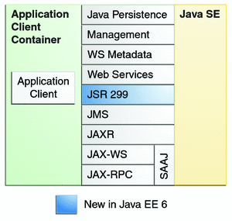
The following sections give a brief summary of the technologies required by the Java EE platform and the APIs used in Java EE applications.
Enterprise JavaBeans Technology
An Enterprise JavaBeans (EJB) component, or enterprise bean, is a body of code having fields and methods to implement modules of business logic. You can think of an enterprise bean as a building block that can be used alone or with other enterprise beans to execute business logic on the Java EE server.
Enterprise beans are either session beans or message-driven beans.
- A session bean represents a transient conversation with a client. When the client finishes executing, the session bean and its data are gone.
- A message-driven bean combines features of a session bean and a message listener, allowing a business component to receive messages asynchronously. Commonly, these are Java Message Service (JMS) messages.
In the Java EE 6 platform, new enterprise bean features include the following:
- The ability to package local enterprise beans in a WAR file
- Singleton session beans, which provide easy access to shared state
- A lightweight subset of Enterprise JavaBeans functionality (EJB Lite) that can be provided within Java EE Profiles, such as the Java EE Web Profile.
The Java EE 6 platform requires Enterprise JavaBeans 3.1 and Interceptors 1.1. The Interceptors specification, which is part of the EJB 3.1 specification, makes more generally available the interceptor facility originally defined as part of the EJB 3.0 specification.
Java Servlet Technology
Java Servlet technology lets you define HTTP-specific servlet classes. A servlet class extends the capabilities of servers that host applications accessed by way of a request-response programming model. Although servlets can respond to any type of request, they are commonly used to extend the applications hosted by web servers.
In the Java EE 6 platform, new Java Servlet technology features include the following:
- Annotation support
- Asynchronous support
- Ease of configuration
- Enhancements to existing APIs
- Plug ability
The Java EE 6 platform requires Servlet 3.0.
JavaServer Faces Technology
JavaServer Faces technology is a user interface framework for building web applications. The main components of JavaServer Faces technology are as follows:
- A GUI component framework.
- A flexible model for rendering components in different kinds of HTML or different markup languages and technologies. A Renderer object generates the markup to render the component and converts the data stored in a model object to types that can be represented in a view.
- A standard RenderKit for generating HTML/4.01 markup.
The following features support the GUI components:
- Input validation
- Event handling
- Data conversion between model objects and components
- Managed model object creation
- Page navigation configuration
- Expression Language (EL)
All this functionality is available using standard Java APIs and XML-based configuration files.
In the Java EE 6 platform, new features of JavaServer Faces include the following:
- The ability to use annotations instead of a configuration file to specify managed beans and other components
- Facelets, a display technology that replaces JavaServer Pages (JSP) technology using XHTML files
- Ajax support
- Composite components
- Implicit navigation
The Java EE 6 platform requires JavaServer Faces 2.0 and Expression Language 2.2.

JavaServer Pages Technology
JavaServer Pages (JSP) technology lets you put snippets of servlet code directly into a text-based document. A JSP page is a text-based document that contains two types of text:
- Static data, which can be expressed in any text-based format such as HTML or XML
- JSP elements, which determine how the page constructs dynamic content
The Java EE 6 platform requires JavaServer Pages 2.2 for compatibility with earlier releases, but recommends the use of Facelets as the display technology in new applications.
JavaServer Pages Standard Tag Library
The JavaServer Pages Standard Tag Library (JSTL) encapsulates core functionality common to many JSP applications. Instead of mixing tags from numerous vendors in your JSP applications, you use a single, standard set of tags. This standardization allows you to deploy your applications on any JSP container that supports JSTL and makes it more likely that the implementation of the tags is optimized.
JSTL has iterator and conditional tags for handling flow control, tags for manipulating XML documents, internationalization tags, tags for accessing databases using SQL, and commonly used functions.
The Java EE 6 platform requires JSTL 1.2.
Java Persistence API
The Java Persistence API (JPA) is a Java standards-based solution for persistence. Persistence uses an object/relational mapping approach to bridge the gap between an object-oriented model and a relational database. The Java Persistence API can also be used in Java SE applications, outside of the Java EE environment. Java Persistence consists of the following areas:
- The Java Persistence API
- The query language
- Object/relational mapping metadata
The Java EE 6 platform requires Java Persistence API 2.0.
Java Transaction API
The Java Transaction API (JTA) provides a standard interface for demarcating transactions. The Java EE architecture provides a default auto commit to handle transaction commits and rollbacks. An auto commit means that any other applications that are viewing data will see the updated data after each database read or write operation. However, if your application performs two separate database access operations that depend on each other, you will want to use the JTA API to demarcate where the entire transaction, including both operations, begins, rolls back, and commits.
The Java EE 6 platform requires Java Transaction API 1.1.
Java API for RESTful Web Services
The Java API for RESTful Web Services (JAX-RS) defines APIs for the development of web services built according to the Representational State Transfer (REST) architectural style. A JAX-RS application is a web application that consists of classes packaged as a servlet in a WAR file along with required libraries.
The JAX-RS API is new to the Java EE 6 platform. The Java EE 6 platform requires JAX–RS 1.1.
Managed Beans
Managed Beans, lightweight container-managed objects (POJOs) with minimal requirements, support a small set of basic services, such as resource injection, lifecycle callbacks, and interceptors. Managed Beans represent a generalization of the managed beans specified by JavaServer Faces technology and can be used anywhere in a Java EE application, not just in web modules.
The Managed Beans specification is part of the Java EE 6 platform specification (JSR 316).
Managed Beans are new to the Java EE 6 platform. The Java EE 6 platform requires Managed Beans 1.0.
Contexts and Dependency Injection for the Java EE Platform (JSR 299)
Contexts and Dependency Injection (CDI) for the Java EE platform defines a set of contextual services, provided by Java EE containers, that make it easy for developers to use enterprise beans along with JavaServer Faces technology in web applications. Designed for use with stateful objects, CDI also has many broader uses, allowing developers a great deal of flexibility to integrate different kinds of components in a loosely coupled but type-safe way.
CDI is new to the Java EE 6 platform. The Java EE 6 platform requires CDI 1.0.
Dependency Injection for Java (JSR 330)
Dependency Injection for Java defines a standard set of annotations (and one interface) for use on injectable classes.
In the Java EE platform, CDI provides support for Dependency Injection. Specifically, you can use DI injection points only in a CDI-enabled application.
Dependency Injection for Java is new to the Java EE 6 platform. The Java EE 6 platform requires Dependency Injection for Java 1.0.
Bean Validation
The Bean Validation specification defines a metadata model and API for validating data in JavaBeans components. Instead of distributing validation of data over several layers, such as the browser and the server side, you can define the validation constraints in one place and share them across the different layers.
Bean Validation is new to the Java EE 6 platform. The Java EE 6 platform requires Bean Validation 1.0.
Java Message Service API
The Java Message Service (JMS) API is a messaging standard that allows Java EE application components to create, send, receive, and read messages. It enables distributed communication that is loosely coupled, reliable, and asynchronous.
The Java EE 6 platform requires JMS 1.1.
Java EE Connector Architecture
The Java EE Connector architecture is used by tools vendors and system integrators to create resource adapters that support access to enterprise information systems that can be plugged in to any Java EE product. A resource adapter is a software component that allows Java EE application components to access and interact with the underlying resource manager of the EIS. Because a resource adapter is specific to its resource manager, a different resource adapter typically exists for each type of database or enterprise information system.
The Java EE Connector architecture also provides a performance-oriented, secure, scalable, and message-based transactional integration of Java EE based web services with existing EISs that can be either synchronous or asynchronous. Existing applications and EISs integrated through the Java EE Connector architecture into the Java EE platform can be exposed as XML-based web services by using JAX-WS and Java EE component models. Thus JAX-WS and the Java EE Connector architecture are complementary technologies for enterprise application integration (EAI) and end-to-end business integration.
The Java EE 6 platform requires Java EE Connector architecture 1.6.
JavaMail API
Java EE applications use the JavaMail API to send email notifications. The JavaMail API has two parts:
- An application-level interface used by the application components to send mail
- A service provider interface
The Java EE platform includes the JavaMail API with a service provider that allows application components to send Internet mail.
The Java EE 6 platform requires JavaMail 1.4.
Java Authorization Contract for Containers
The Java Authorization Contract for Containers (JACC) specification defines a contract between a Java EE application server and an authorization policy provider. All Java EE containers support this contract.
The JACC specification defines java.security.Permission classes that satisfy the Java EE authorization model. The specification defines the binding of container-access decisions to operations on instances of these permission classes. It defines the semantics of policy providers that use the new permission classes to address the authorization requirements of the Java EE platform, including the definition and use of roles.
The Java EE 6 platform requires JACC 1.4.
Java Authentication Service Provider Interface for Containers
The Java Authentication Service Provider Interface for Containers (JASPIC) specification defines a service provider interface (SPI) by which authentication providers that implement message authentication mechanisms may be integrated in client or server message-processing containers or runtimes. Authentication providers integrated through this interface operate on network messages provided to them by their calling containers. The authentication providers transform outgoing messages so that the source of each message can be authenticated by the receiving container, and the recipient of the message can be authenticated by the message sender. Authentication providers authenticate each incoming message and return to their calling containers the identity established as a result of the message authentication.
Java EE 6 APIs in the Java Platform, Standard Edition 6 and 7
Several APIs that are required by the Java EE 6 platform are included in the Java Platform, Standard Edition 6 and 7 (Java SE 6 and 7) and are thus available to Java EE applications.
Java Database Connectivity API
The Java Database Connectivity (JDBC) API lets you invoke SQL commands from Java programming language methods. You use the JDBC API in an enterprise bean when you have a session bean access the database. You can also use the JDBC API from a servlet or a JSP page to access the database directly without going through an enterprise bean.
The JDBC API has two parts:
- An application-level interface used by the application components to access a database
- A service provider interface to attach a JDBC driver to the Java EE platform
The Java SE 6 platform requires JDBC 4.0.
Java Naming and Directory Interface API
The Java Naming and Directory Interface (JNDI) API provides naming and directory functionality, enabling applications to access multiple naming and directory services such as LDAP, DNS, and NIS. The JNDI API provides applications with methods for performing standard directory operations, such as associating attributes with objects and searching for objects using their attributes. Using JNDI, a Java EE application can store and retrieve any type of named Java object, allowing Java EE applications to coexist with many legacy applications and systems.
Java EE naming services provide application clients, enterprise beans, and web components with access to a JNDI naming environment. A naming environment allows a component to be customized without the need to access or change the component’s source code. A container implements the component’s environment and provides it to the component as a JNDI naming context.
A Java EE component can locate its environment naming context by using JNDI interfaces. A component can create a javax.naming.InitialContext object and look up the environment naming context in InitialContext under the name java:comp/env. A component’s naming environment is stored directly in the environment naming context or in any of its direct or indirect subcontexts.
A Java EE component can access named system-provided and user-defined objects. The names of system-provided objects, such as JTA UserTransaction objects, are stored in the environment naming context java:comp/env. The Java EE platform allows a component to name user-defined objects, such as enterprise beans, environment entries, JDBC DataSource objects, and message connections. An object should be named within a subcontext of the naming environment according to the type of the object. For example, enterprise beans are named within the subcontext java:comp/env/ejb, and JDBC DataSource references are named within the subcontext java:comp/env/jdbc.
JavaBeans Activation Framework
The JavaBeans Activation Framework (JAF) is used by the JavaMail API. JAF provides standard services to determine the type of an arbitrary piece of data, encapsulate access to it, discover the operations available on it, and create the appropriate JavaBeans component to perform those operations.
Java API for XML Processing
The Java API for XML Processing (JAXP), part of the Java SE platform, supports the processing of XML documents using Document Object Model (DOM), Simple API for XML (SAX), and Extensible Stylesheet Language Transformations (XSLT). JAXP enables applications to parse and transform XML documents independently of a particular XML processing implementation.
JAXP also provides namespace support, which lets you work with schemas that might otherwise have naming conflicts. Designed to be flexible, JAXP lets you use any XML-compliant parser or XSL processor from within your application and supports the Worldwide Web Consortium (W3C) schema.
Java Architecture for XML Binding
The Java Architecture for XML Binding (JAXB) provides a convenient way to bind an XML schema to a representation in Java language programs. JAXB can be used independently or in combination with JAX-WS, where it provides a standard data binding for web service messages. All Java EE application client containers, web containers, and EJB containers support the JAXB API.
The Java EE 6 platform requires JAXB 2.2.
SOAP with Attachments API for Java
The SOAP with Attachments API for Java (SAAJ) is a low-level API on which JAX-WS depends. SAAJ enables the production and consumption of messages that conform to the SOAP 1.1 and 1.2 specifications and SOAP with Attachments note. Most developers do not use the SAAJ API, instead using the higher-level JAX-WS API.
Java API for XML Web Services
The Java API for XML Web Services (JAX-WS) specification provides support for web services that use the JAXB API for binding XML data to Java objects. The JAX-WS specification defines client APIs for accessing web services as well as techniques for implementing web service endpoints. The Implementing Enterprise Web Services specification describes the deployment of JAX-WS-based services and clients. The EJB and Java Servlet specifications also describe aspects of such deployment. JAX-WS-based applications can be deployed using any of these deployment models.
The JAX-WS specification describes the support for message handlers that can process message requests and responses. In general, these message handlers execute in the same container and with the same privileges and execution context as the JAX-WS client or endpoint component with which they are associated. These message handlers have access to the same JNDI java:comp/env namespace as their associated component. Custom serializers and deserializers, if supported, are treated in the same way as message handlers.
The Java EE 6 platform requires JAX-WS 2.2.
Java Authentication and Authorization Service
The Java Authentication and Authorization Service (JAAS) provides a way for a Java EE application to authenticate and authorize a specific user or group of users to run it.
JAAS is a Java programming language version of the standard Pluggable Authentication Module (PAM) framework, which extends the Java Platform security architecture to support user-based authorization.

